

Make Your Mark Inclusive Volunteering Conference 2026: Power in Partnership

Teams guidance
We're looking forward to welcoming you to the Make Your Mark Conference on Wednesday 4 February 2026!
This document contains everything you need to know about how to join us via Teams.
If you need any other information or help at any stage, please get in touch at hello@makeyourmark.scot and let us know - we're happy to help.

Introduction 3
Join 3
Join by link 3
Join from calendar or ID 4
Join with a meeting ID from your Microsoft Teams app 4
If you don’t have a Microsoft Teams account 5
Audio & video settings 6
Mute or unmute your microphone during a meeting 6
Using video in Microsoft Teams 7
Interact during a meeting 9
Raise your hand 9
Lower your hand 9
Reactions 10
Chat 10
Breakout rooms 14
Slido 14

Introduction
This guidance document provides information about using Microsoft Teams to join the conference online. The conference will be referred to as the “meeting” in this guidance, in line with Microsoft Teams language. This document combines text descriptions and screenshots of the process that is being described. Images include alt text.
During the conference, members of the event team will be in the Microsoft Teams meeting to provide support and assist with technology questions and troubleshooting. They will identify themselves verbally and via text in the chat function.
If you are unfamiliar with the Microsoft Teams platform, you can access a variety of help and support videos and text via the Microsoft Teams website.
If you have further questions after reviewing this guidance, please contact developmentandcommunity@hes.scot for support.

Join

Join by link
All you need to join the Microsoft Teams meeting is a link. This will be emailed to you in the days preceding the conference, as well as on the morning of. If you haven’t received the link the morning of the conference, email us at hello@makeyourmark.scot.

Select Click here to join the meeting in your meeting invite to be taken to a page where you can choose to either join on the web or download the desktop app. If you already have the Microsoft Teams app, the meeting will open there automatically.
If you don’t have a Microsoft Teams account, you can enter your name to join the meeting. If you do have a Microsoft Teams account, select Sign in to join. Then you will enter the meeting lobby where the event team will admit you.

Join from calendar or ID
- Select Calendar on the left side of Microsoft Teams to view your meetings.
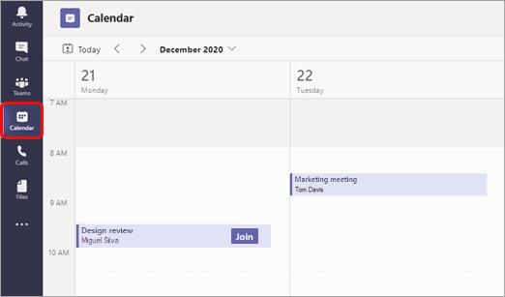
- Find the meeting you want and select Join. Alternatively, when the meeting is started, you'll get a notification you can use to join.

Join with a meeting ID from your Microsoft Teams app
- From your Microsoft Teams Calendar, select Join with an ID.
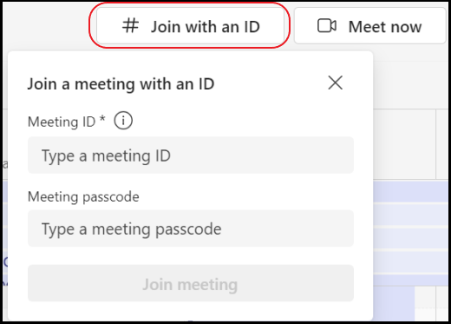
2. Enter a meeting ID and passcode. To find both the meeting ID and passcode, go to your calendar in Microsoft Outlook. Open the meeting you want to join. At the bottom of the meeting invitation under Or join by entering a meeting ID, you'll find the ID and passcode. Alternatively, go to your email mailbox to open the email with the information about the conference.
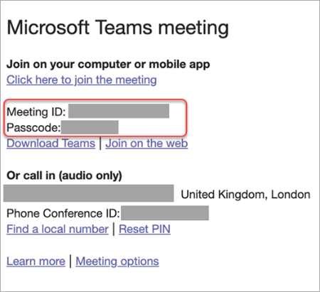
3. Select Join meeting to join the meeting as a participant.

If you don’t have a Microsoft Teams account
You can join a Microsoft Teams meeting anytime, from any device, whether or not you have a Microsoft Teams account. If you don't have an account, follow these steps to join.
- Go to the meeting invite and select Click here to join the meeting (see page one for conference link).
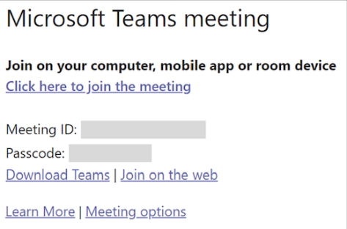

- That will open a web page, where you'll see two choices: Continue on this browser and Join on the Teams app. You don't need to install the Microsoft Teams app to join the meeting.
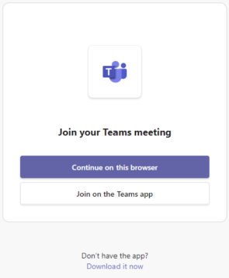

- If you join the meeting on your browser, Microsoft Edge or Google Chrome are recommended web browsers to use. Your browser may ask if it's okay for Microsoft Teams to use your mic and camera. When you select Allow, you can always turn off your mic and/or video once you join the meeting.
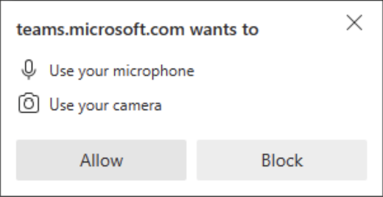

- When you're ready, select Join now.

- You will enter the meeting lobby to wait for a conference team member to admit you into the meeting.

Audio & video settings

Mute or unmute your microphone during a meeting
To turn on your mic during a meeting, select Mic in meeting controls at the upper-right area of your screen. To turn off your mic, select Mic again to mute yourself.
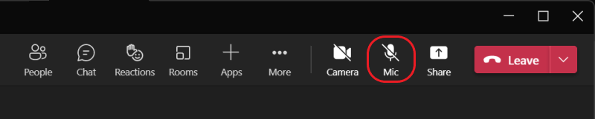

Using video in Microsoft Teams
There are a lot of ways to customise your video experience—and the video you share with others—when you join a Microsoft Teams meeting.

Turn your video on or off
To better enable digital attendees to view the content and speakers, we will ask you to turn your video off. We will tell you verbally and in text via the chat if we would like to invite you to turn your video on at any time.
To turn off your video, go to the meeting controls and select Camera . If you see the line through the video icon, your video is turned off.


Use video filters
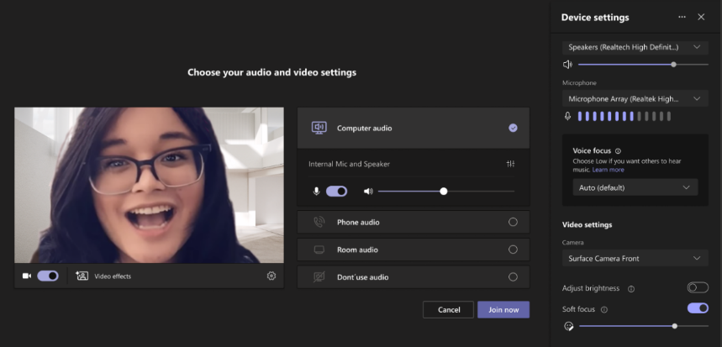
Customise your video feed with the video filters like Adjust brightness. Adjust brightness enhances the video quality when lighting is poor. Filters are turned off by default. To apply video filters, go to the Device Settings panel > Video Settings, then turn on the toggle next to your desired filter.

Change your view
Customise how you see other people's video during a Microsoft Teams meeting with Views. For example, you may want to see as many video feeds as you can at one time in a large meeting. As a reminder, we will ask you to turn your video off during the conference in order to give greater screen space to the speakers and the content.

Gallery
Gallery is the default view during a Teams meeting.
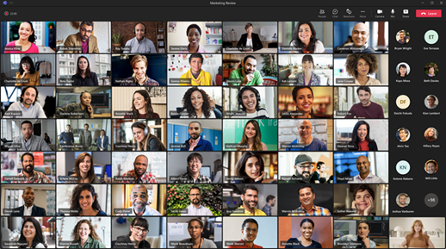
For people who haven't turned on their videos, Teams shows their profile pic instead (or their initials if they haven't added one).

Focus
Focus is available during presentations and when content is being shared on the screen. This is the view to choose when you'd like to pay close attention to the content without the distraction of seeing people's video feeds.
In the meeting controls, select Views and choose Focus on content.

Pin someone's video
To pin someone's video to your view regardless of who's talking, select More options in their video feed (next to their name) and choose Pin for me. This means that you will continue to see this person’s video on your screen at all times for your own view, others won't see what you have pinned. If you no longer want a video to be pinned, select More options > Unpin for me.

Spotlighting
Spotlighting a video is like pinning it for everyone in the meeting. During the conference, conference team members will spotlight the speakers during their presentations, the panel members, and the BSL interpreters. You are not able to turn off the spotlight, as this is provided for all attendees and is necessary to ensure that the live conference and recording provide access to the individuals speaking and the BSL interpretation. Please refer to instructions on Focus for amending the view on your screen to make the presentations appear larger on your screen.

Interact during a meeting

Raise your hand
During a meeting, you can raise your hand virtually to let people know you want to contribute without interrupting the conversation.
In the meeting controls at the top of the screen, select Raise your hand Everyone in the meeting will see that your hand is raised.

Lower your hand
Microsoft Teams detects when you've spoken, and a notification will inform you that your hand will automatically be lowered. Select Keep it raised if you still want to show your hand raised.

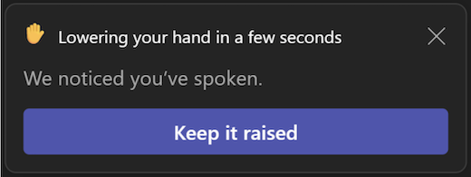
If you haven't yet spoken but want to lower your hand or if your hand does not lower automatically, return to the meeting controls at the top of your meeting view and select Raise your hand or lower hand to put your hand down.

Reactions
During your meeting, select React in the meeting controls at the top of the meeting view to share your reaction to what's being shared. Choose from a range of live reactions, including:
- Like 
- Love 
- Applause 
- Laugh 
- Surprise 
Your reaction will pop up momentarily at the bottom of your meeting and over your profile picture and will float up from the bottom of the screen for a few seconds.

Chat

View and send messages
In your meeting controls, a red dot on the Show conversation icon indicates that someone posted a message.

To view the message, select Show conversation .
The meeting chat window opens to the right of the main screen.
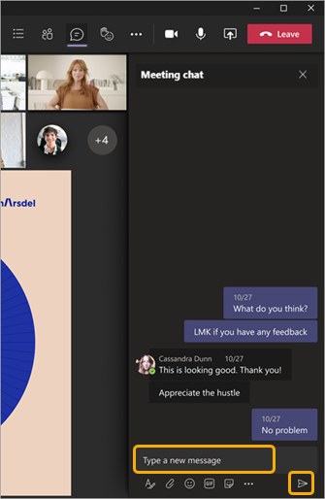
To send a message, compose it in the text box and then select Send .
To hide chats from appearing in the main meeting window, select More actions and choose Don’t show chat bubbles from the menu options.
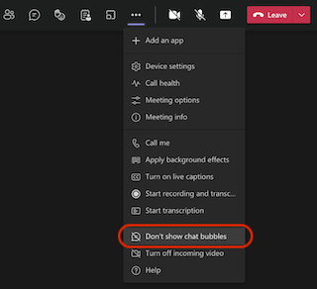

Reply to a specific message in chat in Microsoft Teams
You can reply to a specific message in the chat. This way, people will have helpful context when they read your reply. In chats, there can be replies back and forth. When you reply to a specific message, you add clarity to the context of your message.
- On the left side of Teams, select Chat to open the chat list.
- Find the chat you want, and then go to the message you want to reply to.
- Hover over the message and choose More options > Reply.
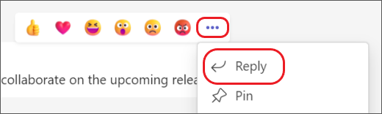
- The message you selected will appear in the compose box. Type your reply in the compose box and select Send .

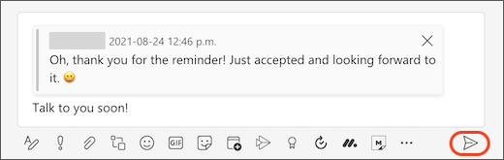

Reply to multiple messages at once
- Hover over a message and choose More options > Reply.
- Repeat step one for each message you want to reply to.
- The messages you selected will appear in the compose box. Type your reply in the compose box and select Send
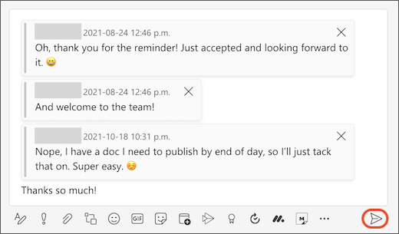

How to find the original message
When you see a reply to a specific message in Chat, it’s simple to find the original message. Select the message preview in the compose box or in the chat, and Teams will scroll up to the location of that particular message.
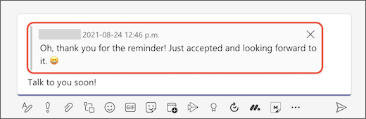

Adding text on a new line in chat
If you press Enter in a chat, the message will be sent. If you want to start a new paragraph or a new line instead of sending the message, press Shift+Enter to insert the line break, then select Send to send it.

Breakout rooms
Digital workshops will be hosted on a separate Teams link that will be emailed to you ahead of the event. Digital workshops will have the option to have breakout rooms within the Microsoft Teams meeting. You will be assigned a breakout room if applicable. At the end the time allotted for breakout rooms, you will be moved automatically back to the main meeting. If you have any issues, contact the conference team members who are supporting digital attendees during the conference.

Slido
The event will use Slido throughout for audience interactivity. You can log in to Slido on whatever device you are accessing the meeting on, but you may find it easier to have a separate smart phone, device or additional computer screen to display it on. There will be a practice session for everyone at the start of the event.

